**Frontend Project Report**

on

# Ecommerce Shopping Site

# Using HTML, CSS and JavaScript

# Total Number of pages in Project: 20

# Bachelor of Engineering

## IN

**COMPUTER SCIENCE AND ENGINEERING**

**Submitted by:**

**Abhimanyu Kashyap (Roll no:2110990042)**

**Group no. 5**

**Under the supervision of**

**Mr. Lavish Arora, CSE Dept.**



**CHITKARA UNIVERSITY INSTITUTE OF ENGINEERING AND TECHNOLOGY**

**Rajpura, Punjab**

## Department of Computer Sc. & Engineering

### ACKNOWLEDGEMENT

I would like to extend our heartfelt gratitude to the individuals and organizations who played a significant role in the successful completion of our college front-end project developed with JavaScript, HTML, and CSS. Their invaluable support and contributions were instrumental in the creation of this project.

I would like to thank:

Our Faculty and Instructors: Our college faculty and Mr. Lavish Arora sir who provided us with guidance, knowledge, and the opportunity to explore and apply front-end development skills. Your support and mentorship were indispensable throughout this project.

Open-Source Community: The open-source community, which provided an array of resources, libraries, and tools that made the development process smoother and more efficient. I greatly appreciate the open-source contributions that fueled our project.

College Support Services: The college's support services, including the library, IT department, and administrative staff, who made resources, facilities, and technical assistance available to us during the course of this project.

This project allowed us to apply the knowledge and skills I acquired during our college education. It was a valuable learning experience, and I am grateful for the opportunities it provided.

I am committed to continuous improvement and the pursuit of knowledge in the field of front-end development. This project marks the beginning of our journey, and I am excited to take what I've learned into our future endeavors.

Thank you to everyone who contributed to this project's success.

Sincerely,

Abhimanyu Kashyap

Chitkara University

CONTENTS

----------------------------------------

Introduction………………………………………………………………. i

Acknowledgement…………………………………………………………. ii

Why choose APPLIANCES……. …………………………………………iii

Project Overview………….………………………………………………. iv

Goals and Challenges……………………………………………………. v

Future Scope……………………………………………………………….vi

**CHAPTER 1: INTRODUCTION**

* 1. **Objective:**

Welcome to our college front-end project, a showcase of our skills and knowledge in web development. This project was created using JavaScript, HTML, and CSS to demonstrate our ability to design a user-friendly and visually appealing website. Our primary focus was on delivering an exceptional user experience while applying best practices in front-end development.

This project allowed us to apply what we've learned and gain practical experience in the field. It reflects our dedication to web development and showcases our problem-solving and skills. In the following sections, we'll delve into the project's features and technologies used to bring it to life. Thank you for joining us on this journey through our project.

* 1. **Introduction to technology used to make project:**

To develop this project, HTML has been used majorly used where different methodologies and tools were applied. Vs Code was the greatest help in developing the above project. More on the technologies and methods used for the project can be seen below:

**HTML:** HTML stands for Hypertext Markup Language. It is the standard markup language used to create and structure content on the World Wide Web. HTML is the backbone of most web pages and is used to define the structure, elements, and layout of a web page, including text, images, links, forms, and multimedia.

HTML uses a system of tags to mark elements on a web page. These tags provide instructions to web browsers about how to display the content. For example, you can use HTML tags to create headings, paragraphs, lists, links, and more.

**CSS:** CSS stands for Cascading Style Sheets. It is a stylesheet language used for describing the presentation and visual design of web pages written in HTML and XML. CSS allows web developers to control the layout, formatting, and appearance of elements on a web page, such as text, images, links, and more.

CSS achieves this by defining rules that specify how HTML elements should be displayed. These rules consist of selectors and declarations. CSS provides a wide range of properties and values that can control everything from colors and fonts to spacing, borders, and positioning. It allows web developers to create visually appealing and responsive web designs while keeping the HTML content separate from its presentation. This separation of content (HTML), presentation (CSS), and functionality (JavaScript) is a fundamental concept in web development, known as the "separation of concerns."

**JavaScript:** JavaScript is a versatile and widely used programming language primarily employed in web development but also increasingly used in other areas, such as server-side development and mobile app development. JavaScript allows developers to add interactivity, manipulate the Document Object Model (DOM), and enhance the functionality of websites and web applications.

Key features and uses of JavaScript include:

* Client-Side Scripting: JavaScript is primarily used on the client side of web development. It runs in the user's web browser, allowing developers to create dynamic and interactive web pages. It can respond to user actions, validate forms, update content, and much more.
* DOM Manipulation: JavaScript can access and modify the Document Object Model (DOM), which represents the structure and content of a web page. This enables dynamic content updates and interaction with HTML and CSS elements.
* Event Handling: JavaScript is used to respond to various events, such as clicks, keyboard input, and form submissions. This allows for user-friendly interfaces and responsive web applications.
* AJAX (Asynchronous JavaScript and XML): JavaScript is essential for making asynchronous requests to web servers, allowing data to be loaded and updated without requiring a full page refresh. This technology is commonly used to create responsive, real-time web applications.
* Cross-Browser Compatibility: JavaScript is supported by all major web browsers, making it a suitable choice for web development. However, developers often use libraries and frameworks to address browser compatibility issues and streamline development.
* Server-Side Development: With the advent of technologies like Node.js, JavaScript can also be used on the server side to build server applications. This enables full-stack JavaScript development and simplifies the development stack for many projects.
* Front-End Frameworks: Several front-end JavaScript frameworks and libraries, such as React, Angular, and Vue.js, have gained popularity for building user interfaces and single-page applications. These frameworks provide a structured approach to building complex web applications.
* Back-End Development: JavaScript is used on the server side, along with Node.js, to create server applications and APIs. This allows for a consistent language and toolset throughout the entire web development stack.

JavaScript is a fundamental tool for modern web development, and its versatility and widespread use have made it an essential skill for web developers. It continues to evolve, with new features and improvements being added to the language and its ecosystem to meet the demands of modern web applications.

**VS Code:**



Figure 5: VS Code

VS Code, short for Visual Studio Code, is a free and open-source code editor developed by Microsoft. It is widely used by developers for various programming languages and offers a rich set of features that enhance productivity and facilitate efficient coding.

Here are some key aspects and features of VS Code:

1**. Lightweight and Fast:** VS Code is designed to be lightweight and fast, providing a smooth and responsive coding experience. It uses minimal system resources and has quick startup times, making it suitable for both small and large projects.

2**. Cross-Platform Support:** VS Code is available for Windows, macOS, and Linux, allowing developers to use the same code editor across different operating systems. This ensures consistency and flexibility for development teams working on different platforms.

3. **Integrated Development Environment (IDE) Features:** Despite being a code editor, VS Code offers many IDE-like features. It provides code completion, syntax highlighting, linting, debugging capabilities, version control integration (such as Git), and more. These features enhance productivity and streamline the development process.

4**. Extensibility:** VS Code has a vast and active extension ecosystem that allows developers to customize and extend the functionality of the editor. Extensions are available for various purposes, such as language support, themes, code snippets, and integration with third-party tools and services.

5**. Integrated Terminal:** VS Code includes an integrated terminal, enabling developers to execute commands, run scripts, and interact with the command-line interface without leaving the editor. This eliminates the need to switch between the editor and an external terminal window.

6**. Version Control Integration:** VS Code seamlessly integrates with popular version control systems like Git, providing features like source code management, commit history visualization, and branch management. Developers can perform version control operations directly within the editor.

7. **Debugging Support:** VS Code offers powerful debugging capabilities with built-in support for various programming languages. It allows developers to set breakpoints, inspect variables, step through code execution, and track down and fix issues in their applications.

8**. IntelliSense:** VS Code provides intelligent code completion and suggestions, known as IntelliSense. It analyzes the code context and offers relevant suggestions, reducing manual typing and helping to catch errors early.

9**. Customization and Theming:** VS Code allows users to customize the editor's appearance, including themes, icon sets, and layout configurations. Users can choose from a variety of pre-installed themes or install additional themes from the extension marketplace.

10**. Remote Development:** VS Code includes remote development extensions that enable developers to work on a remote machine or container directly from the editor. This feature is particularly useful when developing on remote servers or in containerized environments.

Overall, VS Code has gained popularity among developers due to its flexibility, performance, and extensive customization options. Its broad language support and extensive marketplace of extensions make it suitable for a wide range of programming tasks and project types.

**CHAPTER 2: WHY CHOOSE NAME “APPLIANCES “?**

Our e-commerce site primarily focuses on selling a wide range of appliances, such as kitchen appliances, home appliances, or electronic gadgets, the name "Appliances" is highly relevant. It immediately communicates the core focus of your business to potential customers.

1. **Simplicity:** "Appliances" is a simple and easy-to-remember name. It avoids any complexity or ambiguity, which can make it easier for customers to find and remember your website.
2. **Search Engine Optimization (SEO):** Having a keyword-rich domain name like "Appliances" can help improve your site's search engine ranking for related queries. When people search for appliances online, your site may benefit from having a relevant domain name.
3. **Brand Identity:** The name "Appliances" can be a strong foundation for building a brand identity. As you develop your e-commerce business, you can create a memorable logo and design elements around the name to establish a strong brand.
4. **Credibility:** A straightforward and descriptive name like "Appliances" can convey a sense of professionalism and trustworthiness to potential customers. It suggests that you specialize in the products you offer.
5. **Memorability:** Short and concise domain names are often more memorable, making it easier for customers to recall your site when they want to shop for appliances.
6. **Versatility:** While the name "Appliances" suggests a specific product category, you can always expand your product offerings in the future while retaining a relevant and versatile domain name.

**CHAPTER 3: PROJECT OVERVIEW**

The “APPLIANCES” Frontend project uses HTML5 and CSS3 for development along with some famous Js libraries like splide, FontAwesome (for icons) and basic vanilla Js.

**Project name: A P P L I A N C E S**

**Time Taken:** 3 months

**Technologies Used:**

* Hypertext Markup Language (HTML)
* Cascading Style Sheets (CSS)
* JavaScript (JS)
* Font Awesome JavaScript library
* Splide JavaScript library

**Total number pages:**

20

**3.1 Project Preview:**

In the project that has been shown below, I have tried to create a website using HTML, CSS and JavaScript with proper payment gateway i.e., it has some constraints which won’t allow user to put false or empty input in the data base. User can’t use online payment if he hasn’t selected the online payment as the payment mode. Further more basic functionalities like scroll animations and carousels have been added which further adds up to user experience. Colour and aesthetics of site has been kept simple and minimal to further increase user appeal. Demo page and Different category pages are made for easier browsing to find your favourite in a nick of a time.

**3.2 Home Page:**

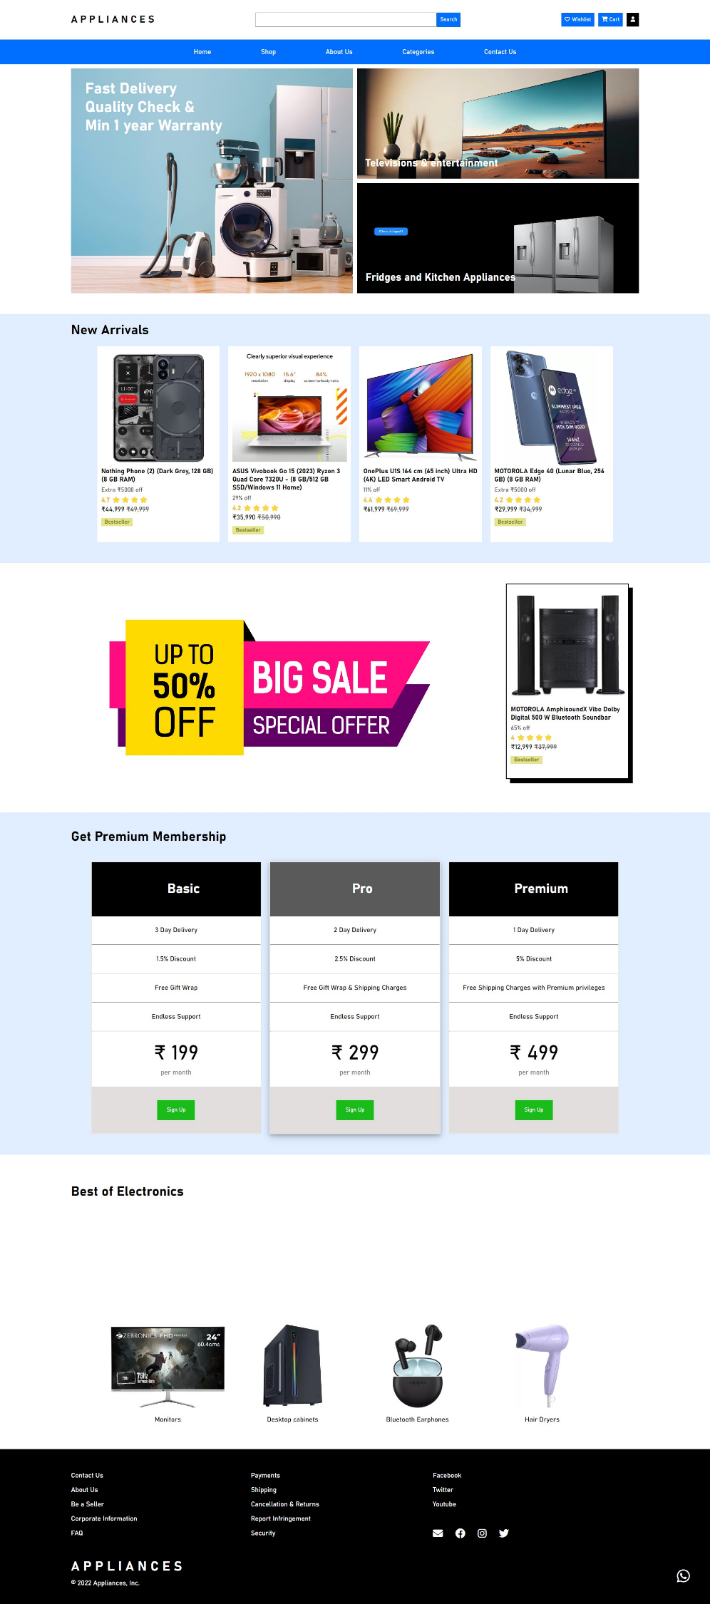<body>: The main content of the webpage is contained within this section.

<div class="container">: This is a container that likely holds the entire content of the webpage.

<div class="whatsapp-contact-btn">: Inside this <div>, there's a button, possibly for initiating contact through WhatsApp.

<div class="sticky-header">: This section represents the page's header and navigation.

Inside the <div class="sticky-header">, there's a navigation bar containing:

A logo with the text

"A P P L I A N C E S".

An input box for searching.

Buttons for wishlist, cart (with a link to the "payment.html" page), and a signup button (with a link to the "login.html" page).

A list of navigation links, including "Home," "Shop," "About Us," "Categories," and "Contact Us."

<div class="categories-panel">: This section likely contains information or links related to product categories. In the provided code, there are two category sections: "Televisions & entertainment" and "Fridges and Kitchen Appliances."

<div class="highlighting-deals-container">: This section showcases "New Arrivals" and provides details about different products.

Several product cards are displayed, each containing an image, product name, discount information, user rating, pricing, and a "Bestseller" label.

<div class="banner-advers">: This section seems to display an advertisement or promotional content. In the provided code, there's an example product card with details.

<div class="highlighting-deals-container">: Another section for displaying content, but in this case, it's promoting a "Get Premium Membership" feature.

Three different membership plans are presented, each with its details and a "Sign Up" button.

<div class="best-of-Electronics">: This section highlights the "Best of Electronics" and contains images and captions related to various electronic product categories.

<footer>: The footer section at the end of the webpage.

The footer includes links to different sections of the website and links to social media profiles.

**3.3 About Us:** <body>: The <body> section contains the main content of the webpage.

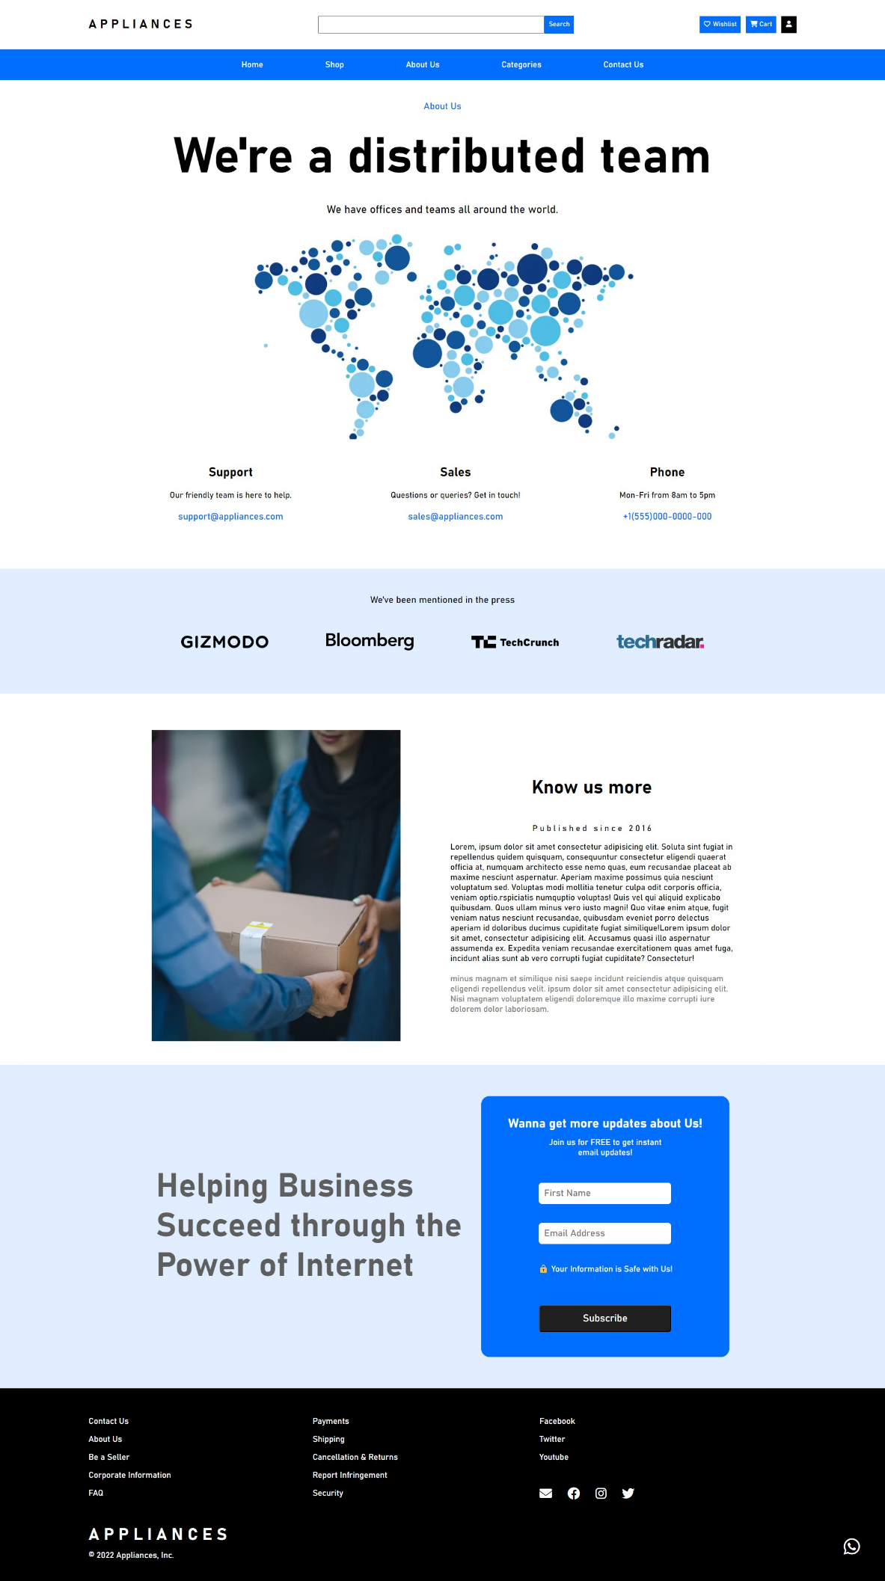

<div class="container">: This is likely a container that holds the entire content of the webpage.

<div class="categories-locatebar">: This section provides a navigation bar with links to "Home," "Shop," "About Us," "Categories," and "Contact Us."

<div class="about-us-front">: This is the primary content section of the "About Us" page.

It includes information about the company, such as its distributed team, offices worldwide, and contact details.

<div class="press-mentions-container">: This section mentions that the company has received press coverage and displays logos of the publications.

<div class="fullpage_container">: This seems to be a two-column layout with an image on the left and text on the right. The text provides information about the company's history and mission.

<div class="dialogue-container">: This section features a dialogue box encouraging users to subscribe for updates, and it collects first names and email addresses.

<footer>: The footer section at the bottom of the webpage.

The footer contains links to different sections of the website and links to social media profiles.

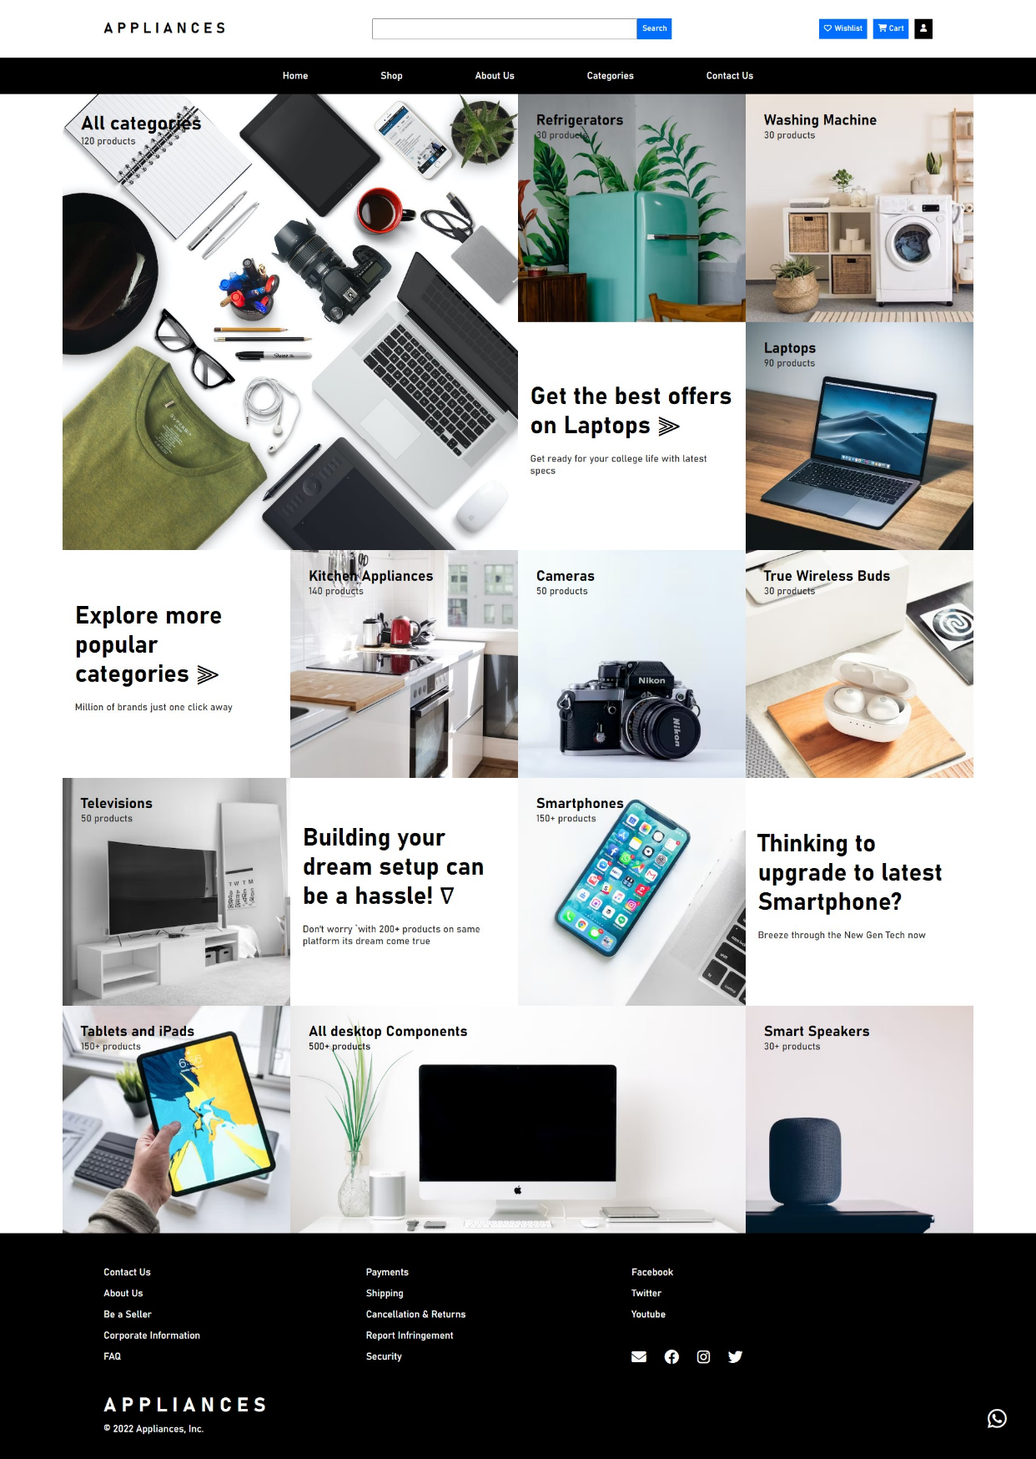 **3.4 Categories Page:** This HTML code segment is responsible for rendering a section of a web page that presents various product categories and subcategories to the users. It's designed to be responsive, adjusting its layout for different screen sizes.

The code begins with a main container, <div class="main-container">, and a link to a login page.

The left-hand side of the container, enclosed in <div class="lhs-cont">, displays the heading "All categories" and indicates there are 120 products in total.

The right-hand side, within <div class="rhs-cont">, showcases several subcategories, each linked to their respective pages. Each subcategory block, like <div class="rhs-bx bx1">, includes the subcategory name and the number of products available.

The code also accounts for a responsive design to adapt to different screen sizes. For smaller screens, it organizes subcategories into multiple columns using the <div class="rhs-responsive"> container.

Each column in the responsive layout contains subcategory information similar to the right-hand side section, making it clear that users can explore and select subcategories they're interested in.

The code concludes with another column-like layout within <div class="rhs-cont-col">, presenting additional subcategories and product counts.

The purpose of this code is to enable users to navigate and explore products based on various categories and subcategories. It's a crucial component of an e-commerce website that helps users find products efficiently.

**3.5 Login and Sign-Up:**

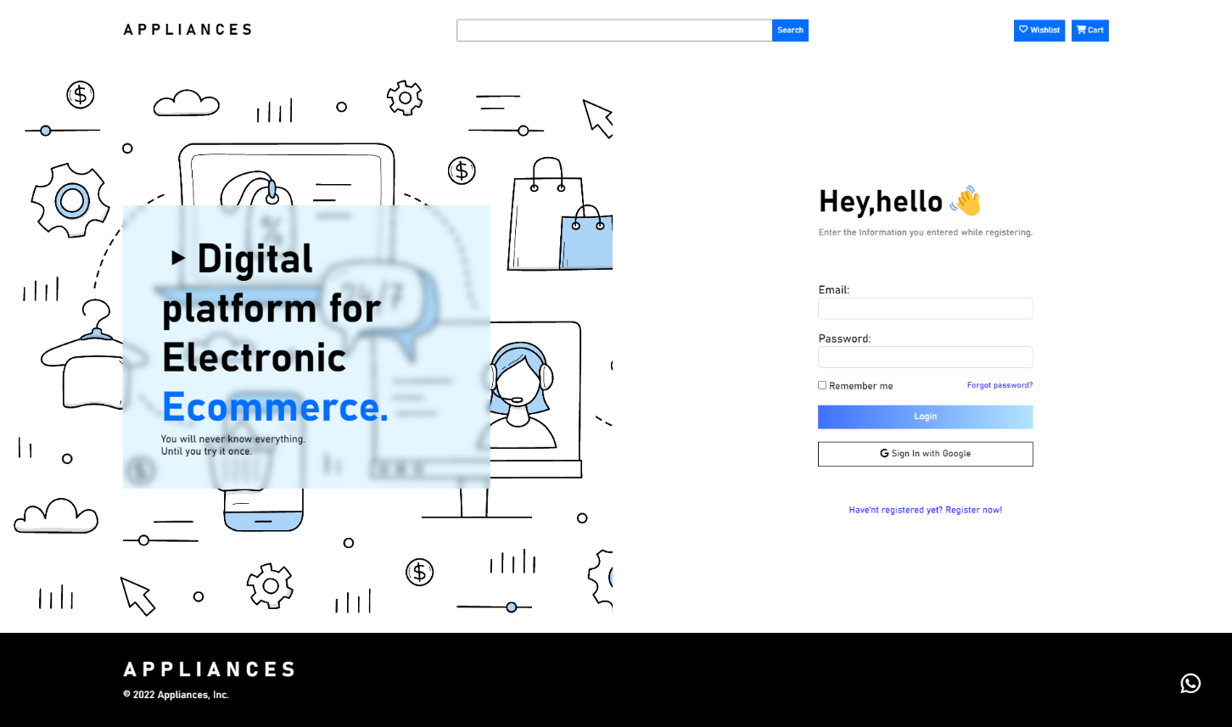

Here HTML forms has been used to create basic interface for Login and Signup.

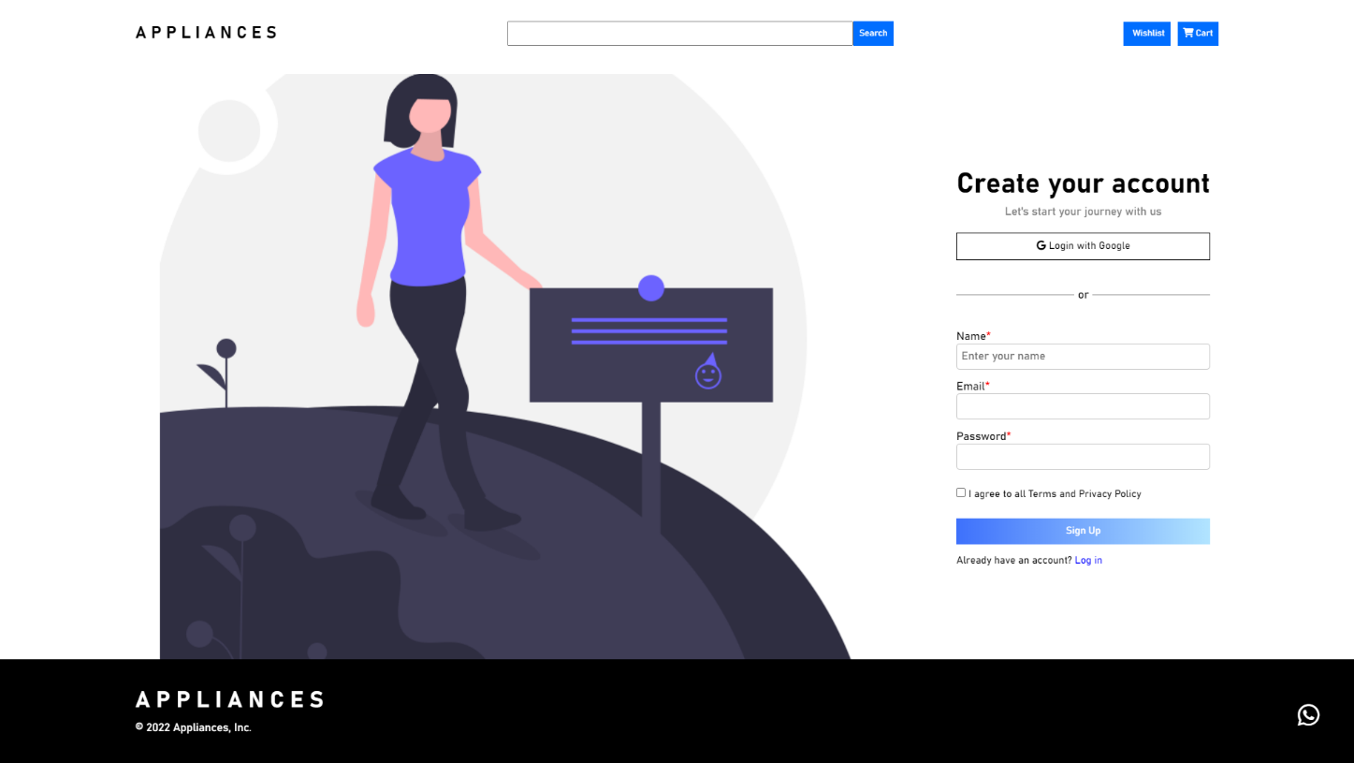

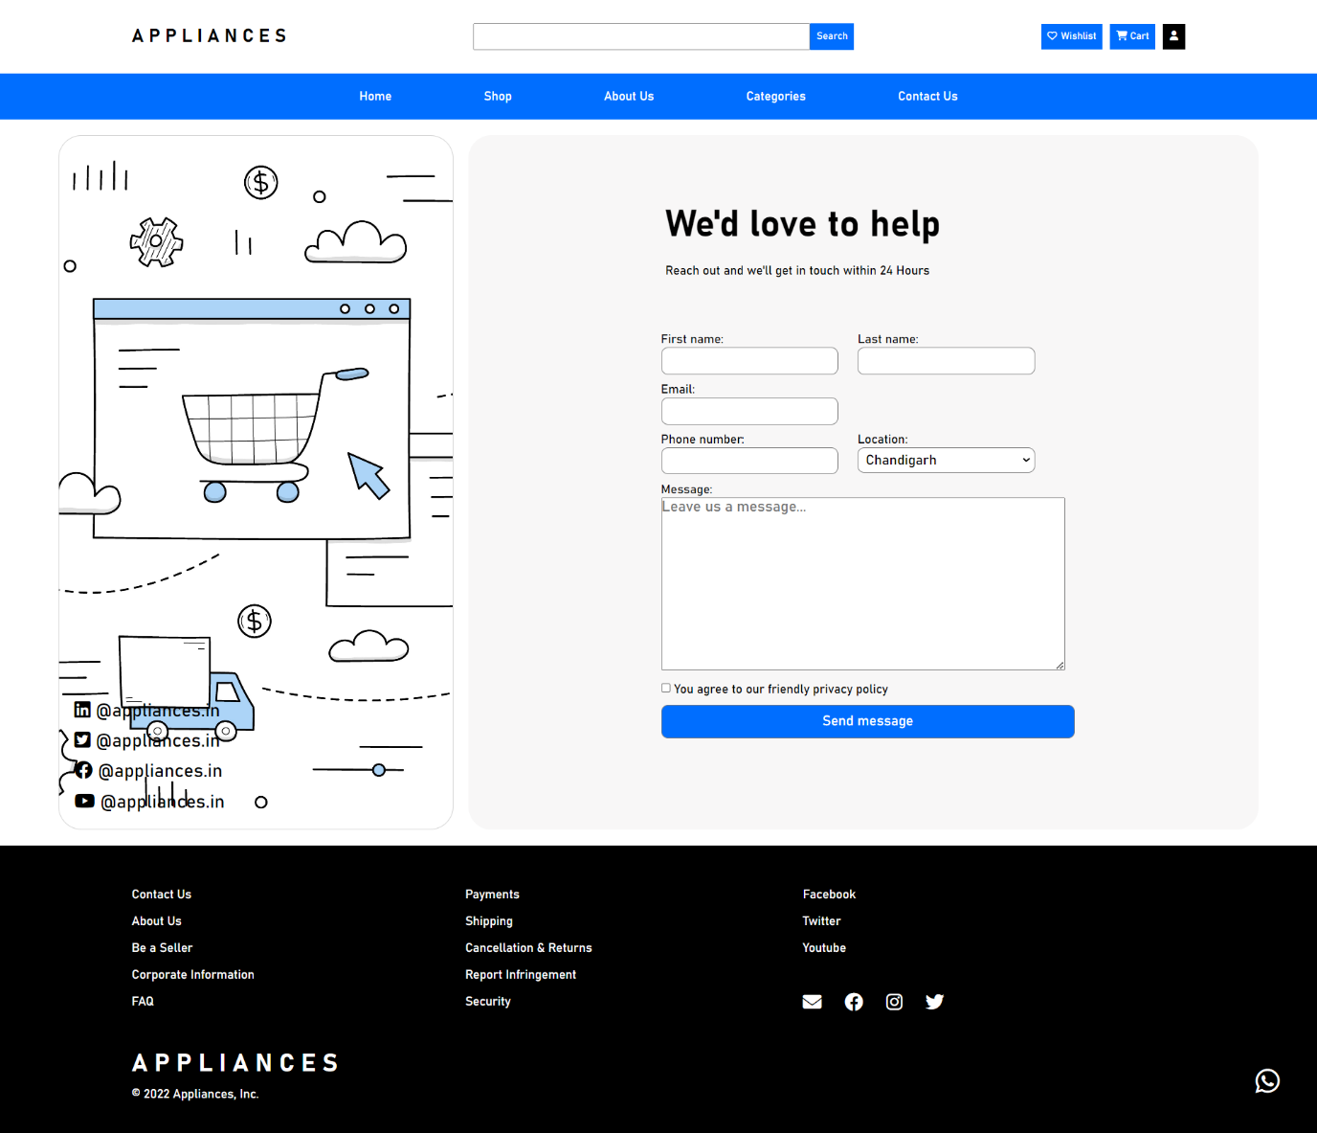**3.6 Contact Us Page:**

<div class="contact-us-body">: This section encompasses a contact form and is divided into two main parts: the left (contact information) and right (the form itself).

Contact Information (Left Side):

It displays links to social media platforms (LinkedIn, Twitter, Facebook, and YouTube) along with the corresponding social media icons and usernames.

Contact Form (Right Side):

<div class="rhs-heading"> contains a title "We'd love to help" and a description indicating a response time within 24 hours.

* The form collects the following user information:
* First Name and Last Name (two separate input fields).
* Email address & Phone Number and Location (with options in a dropdown menu).
* A message text area where users can leave a message.
* A checkbox for agreeing to the website's privacy policy.

The "Send message" button allows users to submit the form.

**3.7 Product Category Page:**

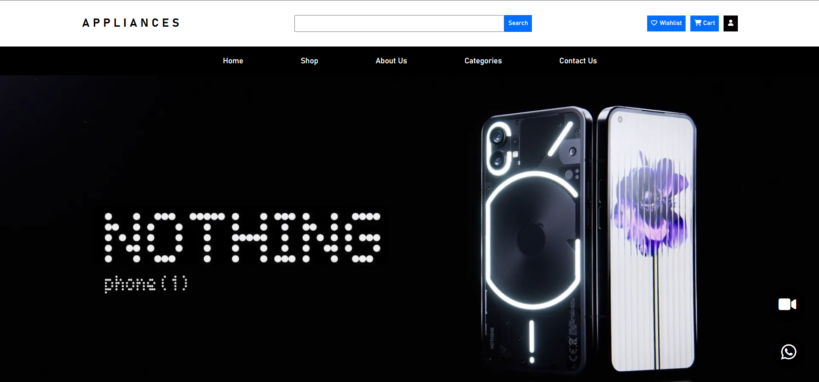

A big project video is added to greet you in the sub-category page. Any video can be added here also floating buttons for demo page and WhatsApp contact button is there.

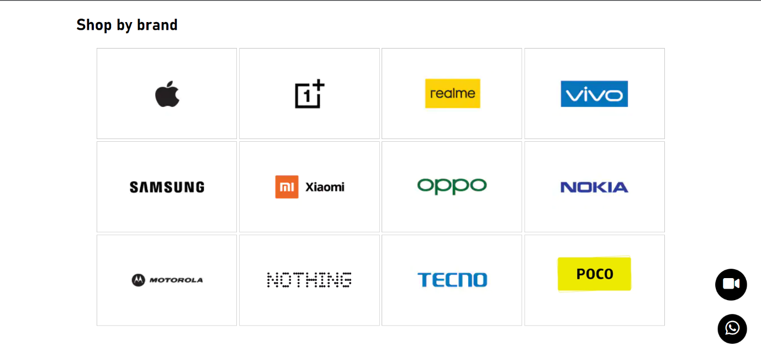

* Video Banner: This section includes a video element that plays a video from the source "/Images/nothing.mp4." The video is set to autoplay, muted, and loop continuously.
* Product Banner:
* The "video-img-adv" section contains an image and a brief description of a product, likely a smartphone. It displays the product image, name, price, and a special offer.
* Shop by Brand:
* This section is titled "Shop by brand" and displays various brand logos, each wrapped in an anchor (<a>) element. Users can click on these links to explore products from different brands.
* 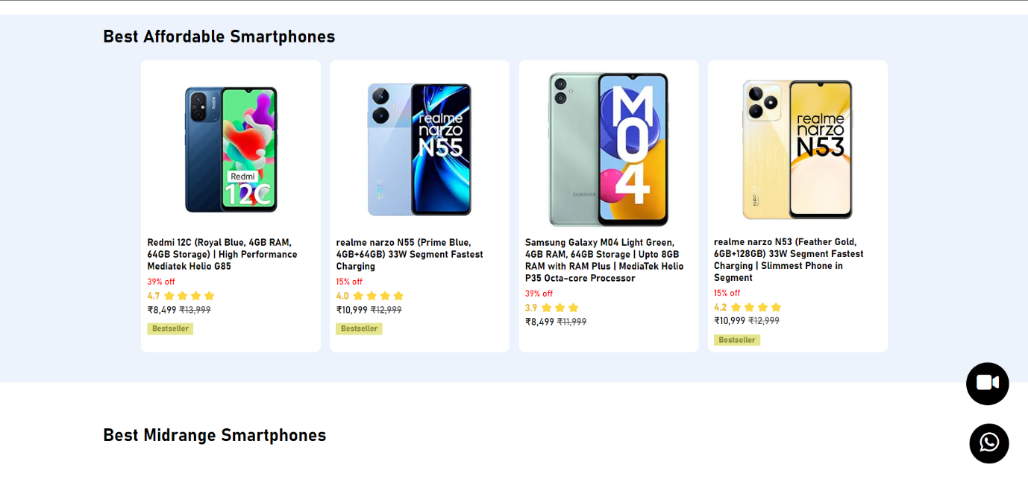Highlighting Deals: The code presents a list of product deals categorized into "Best Affordable Smartphones," "Best Midrange Smartphones," and "Best Premium Smartphones."
* Each product deal includes an image, product name, discount percentage, user rating, and pricing details.
* Explore More: A section titled "Explore more wide range of Smartphones" is provided. It showcases a grid of product boxes, each with an image, product name, starting price, and options to "Buy Now" or "Add to Cart."

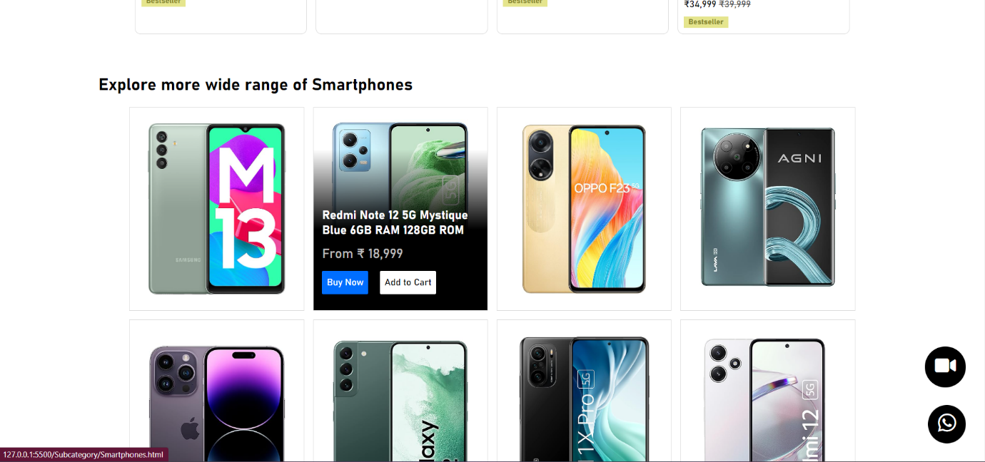

* There is a "View More" button for further exploration.
* Banner Sections: Several empty div elements, such as "banners-club1," "banners-club2," and "banner-club3," suggest space for additional banners or advertisements.
* This HTML code appears to be part of an e-commerce website or product promotion page, primarily focused on showcasing smartphone products and deals, as well as encouraging users to explore further.

**3.8 Demo Page:**

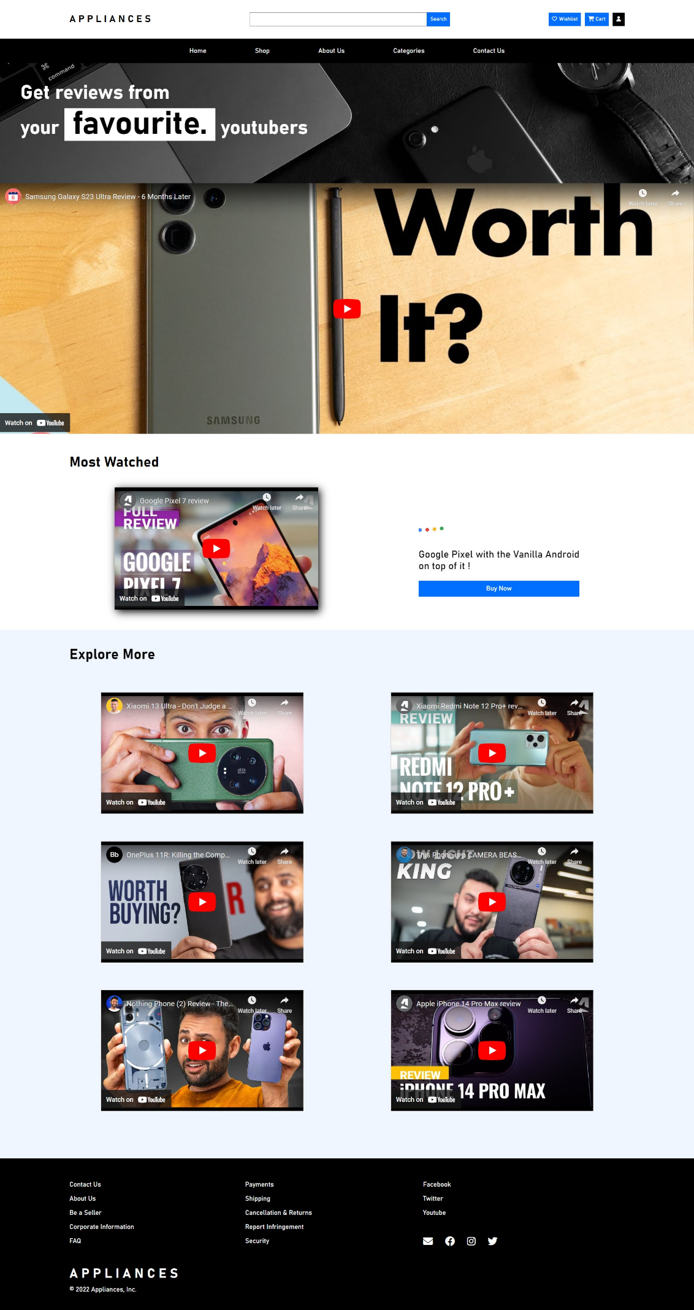

* Page Description: The "page-desc" section contains a heading with a title that reads "Get reviews from your favorite YouTubers."
* Banner Video: The "banner-video" section includes an embedded YouTube video using an iframe. This video likely serves as a featured or promotional video on the webpage.
* Highlighted Review: Within the "highlighted-review" section, there is a "Most Watched" title.
* The "highlighting-link" div contains an embedded YouTube video (iframe), a title, a description related to a product ("Google Pixel with the Vanilla Android on top of it!"), and a "Buy Now" button. This section is likely highlighting a popular or recommended product review video.
* Explore More: The "demo-link-outer" section is designed to allow users to explore additional videos.
* It includes a heading "Explore More." Within the "demo-links" div, multiple embedded YouTube videos (iframes) are provided, each with the potential to link to different video reviews or content.

Overall, the HTML code is structured to promote and display YouTube video content related to product reviews, with an emphasis on providing options for users to explore more vid

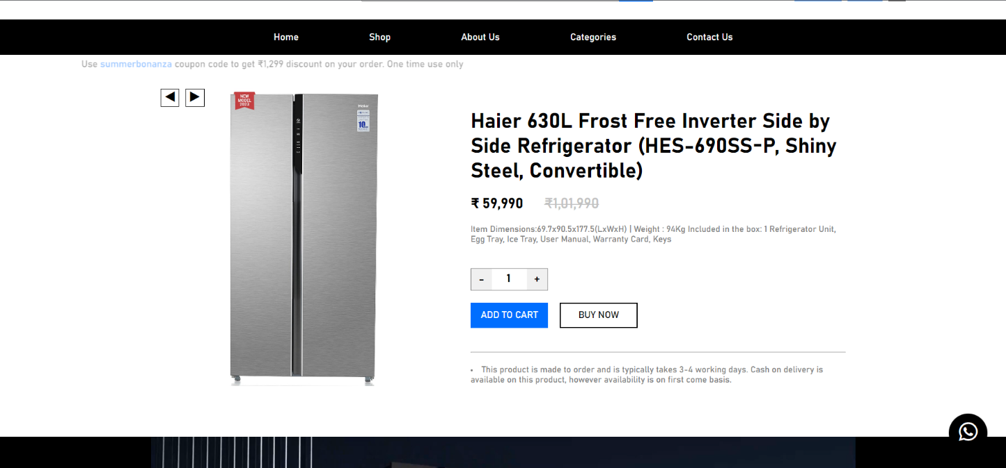 **3.8 Product Overview page:**

**Product Information Section:**

The "product-page" class contains the entire product page.

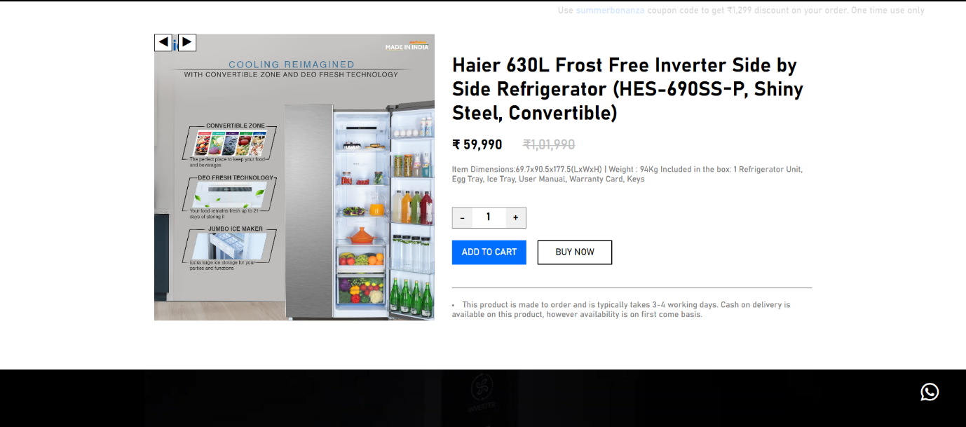The left section, with the ID "lhs-pic-cont," is likely for displaying product images, and it includes navigation buttons for changing images.

* These buttons are used to change images for a better product overview.

The right section, "rhs-product-cont," contains details about the product.

**Product Title and Price:**

The product title is displayed with the class "product-title."

The product's price is shown in Indian Rupees (₹), with the current price and the original price (with a discount) displayed under "product-price."

**Product Description:**

The product description provides details about the item's dimensions, weight, and what is included in the box. It's located within the "product-description" class.

**Quantity Control:**

Users can adjust the quantity they want to purchase using the "+" and "-" buttons, with the current quantity displayed next to them.

**Action Buttons:**

Users can choose to "ADD TO CART" or "BUY NOW" using the respective buttons. These buttons typically initiate the purchase process.

* On clicking ADD TO CART it will trigger confirmation page to weather add the product in cart or not.

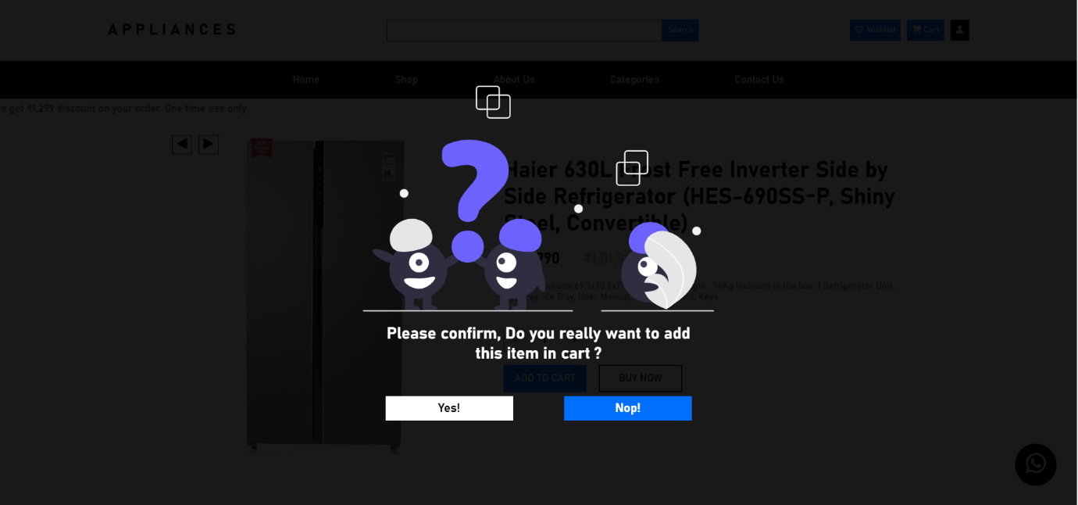

The horizontal line separates the product details from additional information.

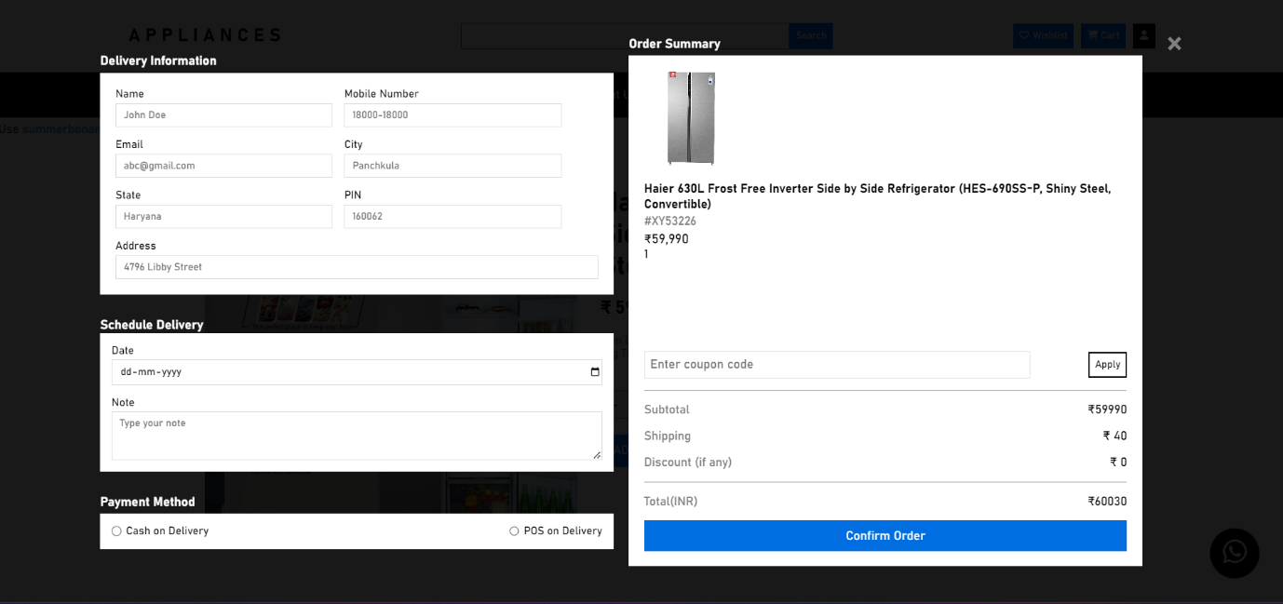There are two list items that provide important information about the product. This includes the estimated delivery time and the return policy.

* On clicking BUY NOW a proper order page will open up, in which we can add any quantity, also it taking all values and content dynamically rather than fixing the html.
* Also, we can add our one-time coupon which discounts for only one time. Further constraints are added to help the input or wrong or null data in database.
* Every time random and unique order id is generated on clicking “Confirm Order”.

This code snippet is a fundamental component of an e-commerce platform's product page, providing a user-friendly interface for customers to interact with and buy products.

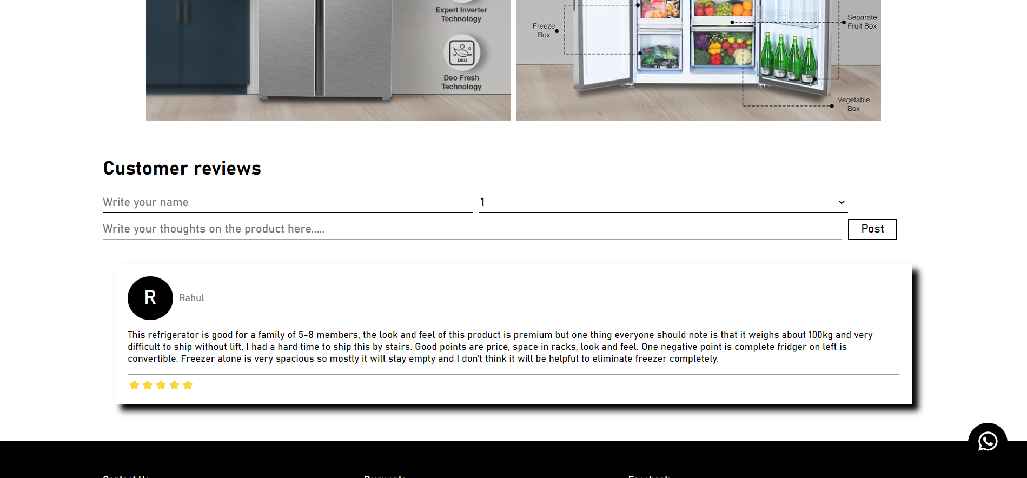

* By using JS, we can add comments and review through input bar added under customer reviews.

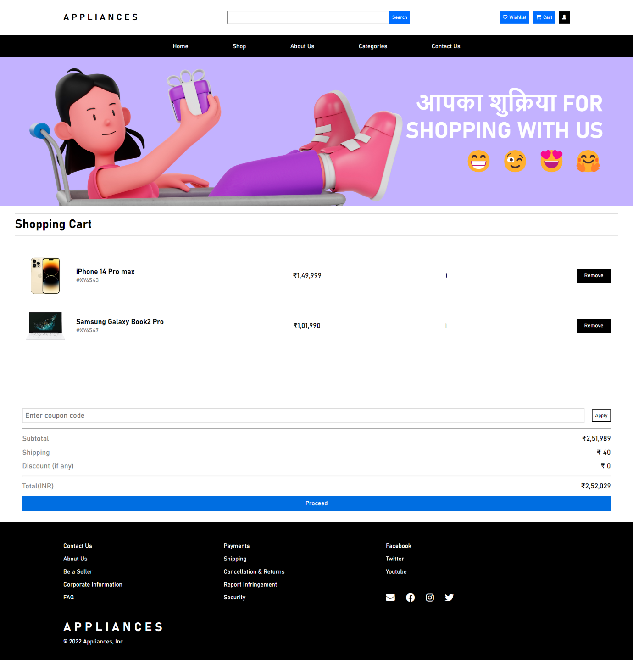**3.8 Cart Page:**

Cart Header: The "cartImage" section displays a banner thanking the user for shopping. It uses emoticons and regional characters to create a friendly and appreciative message.

Cart Overlay:

The "overlay-cont2" div represents an overlay that appears when the user interacts with the shopping cart, displaying the items they have added.

Order Summary: The "order-summary" section contains the main content of the shopping cart.

Individual "cart-item" sections are used to display the details of each product in the cart, including the product name, ID, price, quantity, and a "Remove" button.

Discount Coupon: Users can input a coupon code in the "coupon-inp" input field and apply it by clicking the "cpn-btn" button.

Order Total:

The "order-total" section provides a summary of the order, showing the subtotal (total cost of items), shipping cost, any applied discounts, and the final order total. Each component includes a description and the corresponding amount.

Proceed to Checkout:

The "confirm-order" button allows users to proceed to the checkout process, typically by redirecting them to a delivery details page.

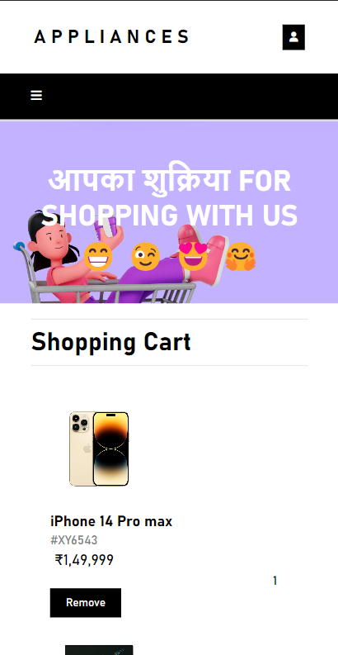

**Responsive Layout:** This page is also made to work on any device with any aspect-ratio.

Many breakpoints have been used to achieve this. Also, a navigation sidebar has been made which is accessible using JavaScript.

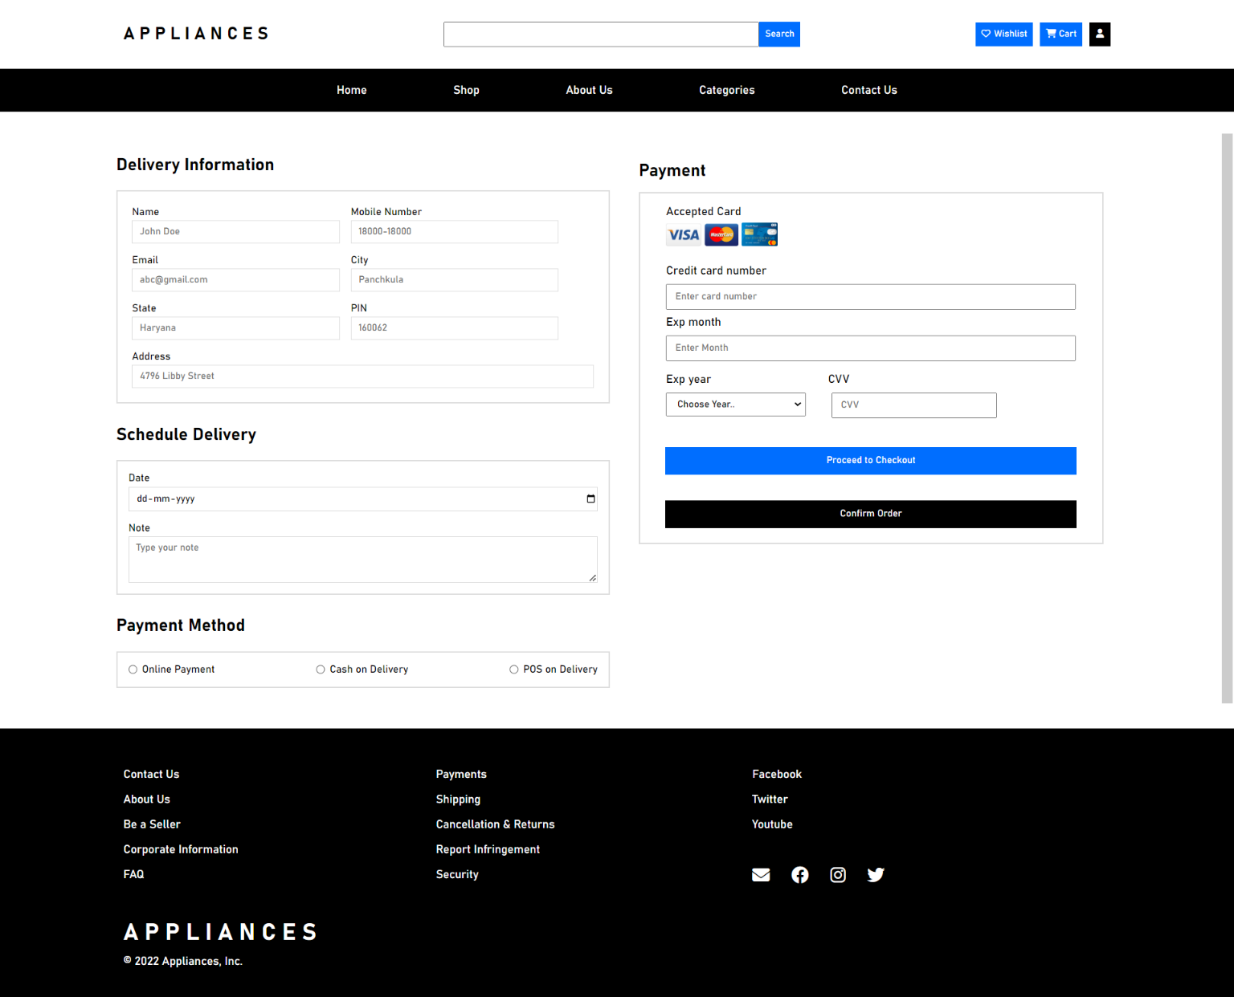**3.8 Delivery Details Page:**

Typical HTML form format is used to keep layout simple and clutter-free.

Several constraints has also been added here to prevent false input of data in the database.

* Delivery Information: This section is dedicated to gathering user delivery details. It includes fields for the user's name, mobile number, email, city, state, PIN code, and address. This information is crucial for shipping the products to the user's specified location.
* Schedule Delivery: In this part, users can specify their preferred delivery date and leave additional notes or comments regarding the delivery. It's a feature that allows customers to choose when they want to receive their orders.
* Payment Method: Users are presented with payment method options. They can choose between "Online Payment," "Cash on Delivery," or "POS on Delivery." This allows customers to select their preferred payment method.
* Payment Section: This section is related to collecting payment details from users when they choose "Online Payment." Users can enter their credit card number, expiration month and year, and the CVV (Card Verification Value) for online transactions. The card logos are displayed for accepted cards.

There are buttons to either "Proceed to Checkout" or "Confirm Order" depending on the stage of the checkout process.

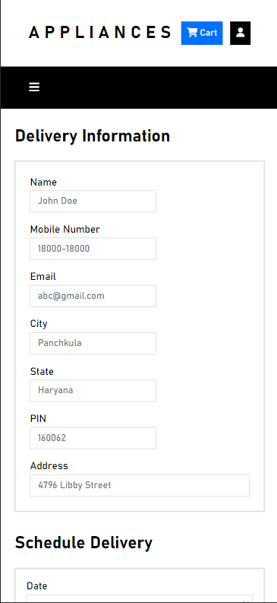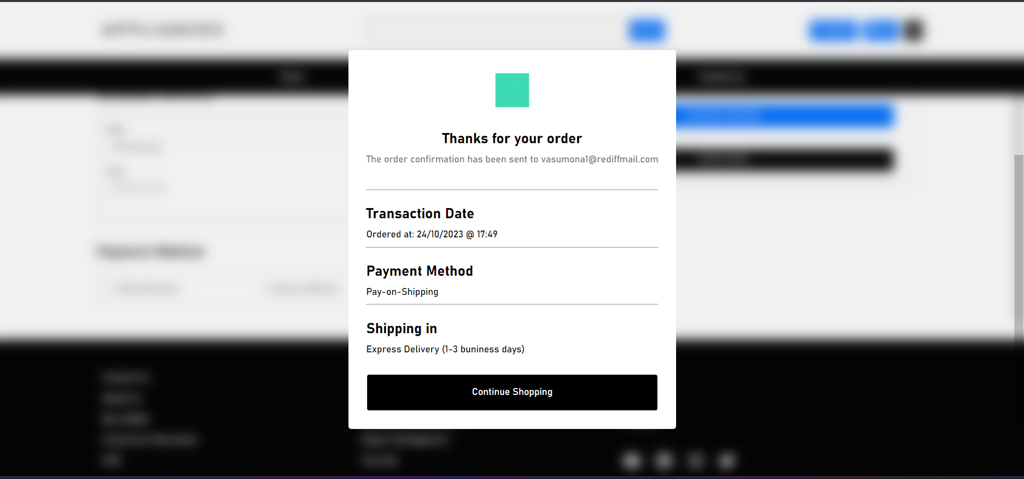

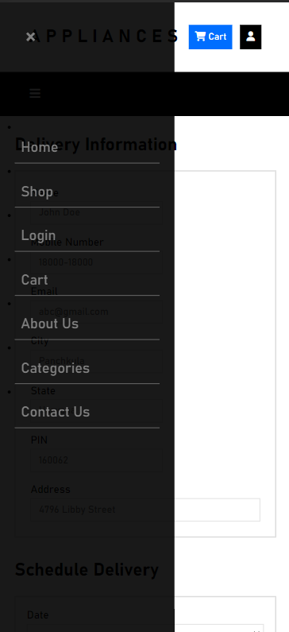

After clicking on the confirm order, it generates a pop-out with real time transaction date/time, Payment method and Shipping details. Also it tells that it sends a email address to your entered e-mail address thus making page more functionally fundamental.

**Responsive Layouts:** This page can also work on any device without distorting basic elements of webpage.

**CHAPTER 4: GOALS AND CHALLENGES**

Goals: -

* **User-Friendly Interface:** Create an intuitive and user-friendly interface to ensure customers can easily navigate through products, categories, and features.
* **Responsive Design:** Develop a responsive design that works seamlessly across various devices and screen sizes to accommodate mobile, tablet, and desktop users.
* **Product Catalogue:** Implement a comprehensive product catalogue with categories, filters, and sorting options for customers to quickly find the appliances they need.
* **Product Details:** Display detailed product information, including specifications, prices, images, and customer reviews.
* **Shopping Cart:** Develop a shopping cart feature where customers can add, edit, and remove items, see the total cost, and proceed to checkout.
* **User Authentication:** Implement user registration and login functionality for a personalized shopping experience, including saved addresses and order history.
* **Payment Integration:** Integrate secure payment gateways to allow customers to make online payments with confidence.
* **Checkout Process:** Streamline the checkout process with clear steps, and provide order summaries and shipping options for the customer's convenience.
* **Search Functionality:** Implement a robust search feature to help users find specific products quickly.
* **Recommendation Engine:** Develop a product recommendation system based on user behaviour and preferences.
* **Performance Optimization:** Optimize website performance for faster loading times to enhance the user experience.
* **Security:** Ensure data security by implementing best practices for user data protection and secure payment transactions.

Challenges: -

* **Cross-Browser Compatibility:** Ensuring that the website works consistently across different web browsers and versions can be challenging.
* **Data Management:** Managing a vast amount of product data, including images, descriptions, and reviews, can be complex and resource-intensive.
* **Payment Gateway Integration:** Integrating and testing payment gateways can be challenging due to security and regulatory requirements.
* **User Authentication and Authorization:** Implementing a secure user authentication system that protects user data and restricts unauthorized access can be complex.
* **Performance Optimization:** Achieving fast load times, especially when handling large images and data, can be challenging.
* **Responsive Design:** Ensuring a seamless user experience on various devices and screen sizes can be technically challenging.
* **Scalability:** Preparing the project for future growth and increased traffic can be a significant challenge.
* **Inventory Management:** Managing real-time inventory, especially for high-demand items, is essential to prevent overselling.

**CHAPTER 5: FUTURE SCOPE**

1. **Mobile App Development:** Consider developing a dedicated mobile application for "APPLIANCES" to provide a seamless and optimized shopping experience for mobile users.
2. **Personalization and AI:** Implement advanced personalization techniques and artificial intelligence to provide customers with product recommendations, personalized content, and a tailored shopping experience.
3. **Progressive Web App (PWA):** Transform your website into a PWA to offer offline access, push notifications, and a more app-like experience for users.
4. **Augmented Reality (AR) Integration:** Allow customers to visualize appliances in their own space using AR technology, which can enhance the decision-making process.
5. **Voice Commerce:** Enable voice search and voice-assisted shopping for hands-free browsing and ordering through voice-activated devices.
6. **Subscription Models:** Introduce subscription services for regular appliance maintenance, filter replacements, or exclusive access to new products.
7. **Global Expansion:** Consider expanding your e-commerce platform to serve customers in different regions and countries to tap into a broader market.
8. **Cross-Selling and Upselling:** Develop cross-selling and upselling strategies to increase the average order value by recommending related products or premium versions.
9. **Enhanced Analytics and Data Insights:** Utilize advanced analytics tools to gain insights into user behavior, sales patterns, and inventory management, which can guide business decisions.
10. **Social Commerce:** Integrate social media features to allow users to discover products through social networks, share their purchases, and interact with your brand on social platforms.